Solution Design Document

Student Reference Portal

1. Project Overview
The Student Reference Portal is a web-based application that stores and displays reference materials for school students across three subjects: Arts, Mathematics, and Technology. Articles can cover biographies of key people, major artworks, historical events, and important concepts. The system supports three types of users: Students, Tutors, and Administrators, each with different levels of access.

2. System Architecture
Architecture Selection
A simple three-layer web application was selected for this project:
- Browser (HTML + JavaScript) talks to PHP pages
- PHP pages talk to a MySQL database
- Everything runs on a single local server using UniServer
Reason for This Architecture
UniServer bundles Apache, PHP, and MySQL together so there is no complicated setup. PHP is straightforward to write and runs on almost any web host. MySQL is free, reliable, and works well with PHP. No frameworks are needed, which keeps the project easy to understand and maintain. A single server setup is suitable for a school project of this size.

Communication Between Layers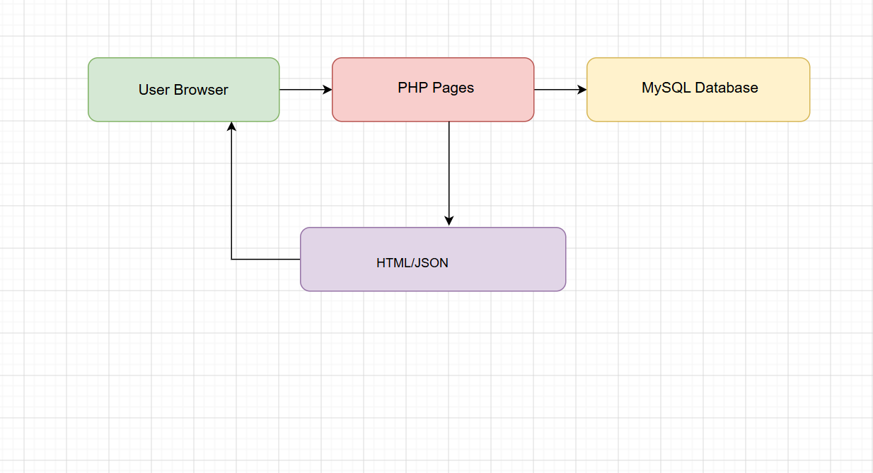
The browser sends requests, PHP processes them and queries the database, then sends results back to the browser.

3. Technology Choices
PHP
PHP was selected as the server-side language because it is easy to learn and widely used in web development education. It connects to MySQL with minimal code using PDO, handles sessions for login which is needed for role-based access, and runs directly on UniServer with no extra installation required.
MySQL
MySQL was selected as the database because it is free and open source. It works perfectly with PHP, supports foreign keys which are used to link articles to people, events, and artworks, and PhpMyAdmin provides a visual interface to manage the database easily during development.
HTML and JavaScript
Plain HTML and JavaScript were selected instead of frameworks like React or Vue. The fetch() API built into modern browsers is enough to handle communication with the backend. This approach is easier to read, debug, and explain in an academic submission and works in any browser without any build steps.

Sessions for Authentication
PHP sessions were selected to manage login state. The session stores the logged-in user's ID, name, and role. Every protected page checks the session at the top using auth.php. This approach is simple and reliable for a single-server application.

4. Database Model

ERD Diagram
Table Descriptions
roles
Stores the three user types: Student, Tutor, Administrator. Keeping roles in a separate table means new roles can be added later without changing the users table structure.
users
Stores login details for everyone who accesses the system. Each user has one role. Passwords are stored as bcrypt hashes, never as plain text.
subjects
Stores the three top-level subjects: Arts, Mathematics, and Technology. Every article belongs to one subject.
categories
Each subject can have multiple categories such as Biography, Painting, Event, and Concept. Categories have a type field so they can be grouped by subject area.
articles
The main content table. Each article belongs to one subject and one category and was created by one user. Articles can be either Published or Draft status.
people
Stores details about notable individuals such as artists or scientists. The born and died columns are stored as SMALLINT instead of YEAR because the YEAR type in MySQL only accepts values from 1901 onwards, which does not work for historical figures like Leonardo da Vinci born in 1452.
events
Stores historical events with a year, type, location, and description. The year column is also SMALLINT for the same reason as the people table.
artworks
Stores details about artworks including medium, dimensions, current location, and the name of the creator.
article_people, article_events, article_artworks
These are junction tables that link articles to people, events, and artworks. One article can reference many people and one person can appear in many articles. ON DELETE CASCADE ensures that if an article is deleted, these links are automatically removed without leaving orphaned records.
Relationship Summary

Table | Related Table | Relationship Type | Link
roles | users | One to Many | One role is assigned to many users
users | articles | One to Many | One user creates many articles
subjects | articles | One to Many | One subject contains many articles
categories | articles | One to Many | One category groups many articles
articles | people | Many to Many | One article references many people, one person appears in many articles
articles | events | Many to Many | One article references many events, one event appears in many articles
articles | artworks | Many to Many | One article references many artworks, one artwork appears in many articles
article_people | articles, people | Junction Table | Resolves the many to many between articles and people
article_events | articles, events | Junction Table | Resolves the many to many between articles and events
article_artworks | articles, artworks | Junction Table | Resolves the many to many between articles and artworks

Reason for This Database Design
Separating content into multiple related tables avoids repeating data. For example, Leonardo da Vinci's details are stored once in the people table and can be linked to as many articles as needed. This follows the principle of normalisation which reduces data duplication and makes updates easier to manage.

5. User Access Design
Role Definitions
Student (role_id = 1)
Students can log in and view the article list. They can search articles by keyword in the title and filter articles by category. They can click View to read the full content of any article. They cannot see Add, Edit, or Delete buttons.
Tutor (role_id = 2)
Tutors have everything a Student can do. In addition they can click Add Article to create new articles and click Edit on any article to update it. They cannot delete articles.
Administrator (role_id = 3)
Administrators have everything a Tutor can do. In addition they can click Delete on any article to permanently remove it and have full control over all content in the system.
Access Control Implementation
auth.php starts a session and provides helper constants for each role. Every page begins with requireLogin() which redirects to login.php if no valid session exists. The role_id stored in the session controls which buttons appear on screen and which actions the API will accept. Even if someone attempts to call the API directly, api.php checks the role before performing any write or delete operation and returns an access denied response if the role is insufficient.

6. File Structure
student_reference_portal/
- db.php database connection
- auth.php session start and role constants
- login.php login form and authentication
- logout.php destroys session and redirects
- index.php main page with role-aware article list
- api.php handles all CRUD operations via fetch
Reason for This File Structure
Each file has one clear responsibility which makes the project easier to navigate and maintain. db.php and auth.php are included at the top of other files so the connection and session code is not repeated. api.php acts as a simple backend that the JavaScript in index.php calls using fetch(), keeping the server logic separate from the presentation.

7. UX Design Decisions
Single Page Layout
All article browsing, viewing, adding, and editing happens on index.php without navigating to a different page. This was chosen because it is simpler to build and faster for the user since the page does not fully reload for every action.
Search and Filter Placement
The search box and category dropdown are placed at the top of the page above the table. This follows standard web conventions where users expect search controls to appear above the results they affect.
Table for Article Listing
A basic HTML table was chosen to display articles because it presents data clearly in aligned rows and columns. Users can quickly scan across a row to see the title, subject, category, author, and status at a glance.
View Panel Placement
When a user clicks View, a panel appears below the table showing the full article content. This avoids opening a new page and keeps the user oriented within the same screen. A Close button hides the panel again when finished.
Form Placement and Behaviour
The form for adding or editing an article appears below the view panel and scrolls into view automatically when opened. This keeps everything on one page while still separating the form visually from the article list.
Role-Based Button Visibility
Buttons only appear if the logged-in user has permission to use them. Students see only a View button. Tutors see View and Edit. Administrators see View, Edit, and Delete. This avoids presenting users with options they cannot use and reduces the chance of accidental actions.
Minimal Styling Approach
The interface uses plain HTML with a simple bordered table and no CSS framework. This was chosen to keep the code readable and to focus on demonstrating the database and access control functionality rather than visual presentation.

8. Security Considerations
Password Storage
Passwords are stored using PHP's password_hash() function which applies bcrypt hashing. Plain text passwords are never stored in the database at any point.
SQL Injection Prevention
All database queries use PDO prepared statements with bound parameters. This prevents SQL injection attacks where a malicious user could enter harmful text in a search or form field to manipulate database queries.
Session-Based Protection
No page or API action works without a valid session. Any attempt to access index.php or api.php without being logged in results in a redirect to login.php or an access denied response.
Server-Side Role Enforcement
Button visibility in the browser is a convenience for the user, not a security measure. The actual enforcement of permissions happens in api.php on the server. A student cannot delete an article even if they bypass the browser interface and send a direct HTTP request to the API.

9. Known Limitations and Future Improvements
Current Limitations
There is no user management interface for administrators so users must be added directly through phpMyAdmin. There is no pagination so a large number of articles will result in a very long table. There is no image upload feature for articles. The search function only matches keywords in the article title and not in the content body. There is no interface for managing people, events, or artworks, which must be done directly in the database.

Possible Future Improvements
Future iterations could add an administrator interface for managing users, pagination for the article list, full-text search across article content, image upload support, and dedicated pages for managing people, events, and artworks through the web interface.

10. Summary
The Student Reference Portal uses PHP, MySQL, and plain HTML running on UniServer. The database contains eleven tables covering users, roles, subjects, categories, articles, people, events, artworks, and their relationships. Access is controlled by a session-based login system where each user's role determines what they can see and do. The interface is a single page that displays all articles in a table with search and filter controls and allows authorised users to add, edit, delete, and view article content without leaving the page.

